**TRIBHUVAN UNIVERSITY**

**INSTITUTE OF ENGINEERING**

ADVANCED COLLEGE OF ENGINEERING AND MANAGEMENTDEPARTMENT OF ELECTRONICS AND COMPUTER ENGINEERING, BALKHU, KATHMANDU



**A Minor Project Report On**

**“Indoor AR Navigation of ACEM”**

**[CT 654]**

**SUBMITTED BY**

Subiddya Panthee-ACE075BCT066

Sudikshya Rajkarnikar-ACE075BCT067

Rabiya Begum-ACE075BCT078

**SUPERVISED BY**

Er. Raisha Shrestha

Er. Narayan K.C.

A minor project submitted to Department of Electronics and Computer Engineering in the partial fulfillment of the requirements for degree of Bachelor of Engineering in Computer Engineering, Balkhu, Nepal

March 14, 2022

# **ACKNOWLEDGEMENT**

We express our deep gratitude to Er. Ajaya Shrestha, Head of Department, Department of Computer and Electronics Engineering and Er. Bikash Acharya, Deputy Head of Department, Department of Computer and Electronics Engineering for their regular support.

We take this opportunity to express our deepest and sincere gratitude to our supervisor Er. Raisha Shrestha and Er. Narayan K.C. for their insightful advice, motivating suggestions, invaluable guidance.

We would like to express our special thanks of gratitude to Er. Dhiren Karki for providing us with his guidance and support in this project.

The in-time facilities provided by the department throughout the Bachelors program are also equally acknowledgeable.

We would like to convey our thanks to the teaching and non-teaching staff of the Department of Electronics & Communication and Computer Engineering, ACEM for their invaluable help and support on our ongoing period of Bachelor’s Degree. We are also grateful to all our classmates for their help, encouragement and invaluable suggestions.

Subiddya Panthee-ACE075BCT066

Sudikshya Rajkarnikar-ACE075BCT067

Rabiya Begum-ACE075BCT078

# **ABSTRACT**

AR Navigation is an Augmented Reality based navigation system that allows users to navigate within large buildings and spaces. The primary objective of our project is to design and build indoor navigation applications for the third floor of ACEM. GPS systems are inaccurate for indoor navigation. In this project Simultaneous Localization and Mapping (SLAM) algorithm is used to locate the device within the environment. The chosen environment for the development is Unity. The four basic modules are AR repositioning, On-Touch Repositioning, and Path Showing with Unity’s NavMesh. Admin upload the map and Users can touch on the screen to set destination, view Minimap and switch view of Minimap.

**Keywords:** *Augmented Reality, Indoor Navigation, Navmesh, Navigation Mesh, Simultaneous Localization and Mapping*

# 

# **TABLE OF CONTENTS**

**ACKNOWLEDGEMENT** I

**ABSTRACT** II

**TABLE OF CONTENTS** III

**LIST OF FIGURES** V

**LIST OF ABBREVIATIONS** VI

**CHAPTER 1** - 1 -

**INTRODUCTION** - 1 -

**1.1 Background** - 1 -

**1.1.1 AR-Core Localization** - 1 -

**1.1.2 Unity Nav-Mesh Navigation** - 1 -

**1.1.3 On-Touch Repositioning** - 2 -

**1.1.4 Path Showing with Augmented Reality** - 2 -

**1.3 Problem Statement** - 2 -

**1.4 Objective** - 3 -

**1.5 Significance of the study** - 3 -

**CHAPTER 2** - 4 -

**LITERATURE REVIEW** - 4 -

**2.1 Background** - 4 -

**2.2 Past Activities** - 5 -

**2.3 Existing Systems** - 5 -

**2.3.1 Google AR Core** - 5 -

**2.3.2 AR Foundation** - 5 -

**2.3.3 MARS (Mobile Augmented Reality)** - 6 -

**2.3.4 Social Media Applications** - 6 -

**2.3.5 IndoorAtlas** - 6 -

**CHAPTER 3** - 7 -

**REQUIREMENT ANALYSIS** - 7 -

**3.1 Hardware Requirement** - 7 -

**3.2 Software Requirement** - 7 -

**3.3 Functional Requirement** - 7 -

**3.4 Non-Functional Requirement** - 8 -

**3.5 Feasibility Study** - 8 -

**3.5.1 Economic feasibility** - 8 -

**3.5.2 Operational feasibility** - 9 -

**CHAPTER 4** - 10 -

**SYSTEM AND ARCHITECTURE** - 10 -

**4.1 USE CASE DIAGRAM** - 10 -

**4.2 DFD (DATA FLOW DIAGRAM)** - 11 -

**DFD LEVEL 0** - 11 -

**DFD LEVEL 1** - 11 -

**DFD LEVEL 2** - 12 -

**CHAPTER 5** - 13 -

**METHODOLOGY** - 13 -

**5.1 ALGORITHMS** - 13 -

**5.1.1 SLAM (Simultaneous Localization and Mapping)** - 13 -

**5.1.2 Unity’s Navigation Mesh** - 14 -

**5.2 SOFTWARE DEVELOPMENT MODEL** - 16 -

**5.2.1 Agile Methodologies** - 16 -

**5.2.2 Programming languages** - 16 -

**5.3** **BLOCK DIAGRAM** - 17 -

**CHAPTER 6** - 18 -

**EXCEPTED OUTPUT** - 18 -

**6.1 MOBILE APPLICATION** - 18 -

**CONCLUSION** - 20 -

**7.1 CONCLUSION** - 20 -

**7.2 LIMITATION OF THE STUDY** - 20 -

**7.3 FUTURE ENHANCEMENT** - 21 -

**REFERENCES** - 22 -

# **LIST OF FIGURES**

# 

# 

# **LIST OF ABBREVIATIONS**

**Symbols/Abbreviations Terms**

GPS Global Positioning System

SLAM Simultaneous Localization and Mapping

BLE Bluetooth Low Energy

VPS Visual Positioning System

MAR Mobile Augmented Reality

# **CHAPTER 1**

# **INTRODUCTION**

## **1.1 Background**

There has been use of various interactive technologies for development of navigation systems that allows users to access information about the location using mobile devices. Augmented Reality is an interactive technology that blends real time digital information using suitable computer interfaces. AR Navigation is an Augmented Reality based navigation system that allows users to navigate within large buildings and spaces. Outdoor navigation system uses Global Positioning System (GPS), satellite images for navigation. These systems are inaccurate for indoor navigation systems so they use different positioning methodologies to pinpoint the user’s location[1].

### **1.1.1 AR-Core Localization**

The real challenge in indoor navigation is positioning, orienting, and tracking a user’s device in the AR world. The motion tracking and environment understanding of ARCore will help us move the person correctly according to our own environment. The person has a camera as a child that looks straight down and renders its view to a raw image used as a Minimap[2].

### **1.1.2 Unity Nav-Mesh Navigation**

The NavMesh is a map of the area where any object can walk. The object can automatically find a path to their destination and move there after a walkable surface is set. Precision is an important aspect for indoor navigation for localization. Finding an optimal route to a destination can be achieved via a couple of methods. When using Unity, we can make use of NavMesh components. We can indicate which surface walkable and pathfinding can be done easily using built in functions[2].

### **1.1.3 On-Touch Repositioning**

The start position synchronization is handled using the on-touch function. The start position is already predefined, and when the user touches the screen start position gets repositioned to the original position. A person which is indicated as a sphere will be able to accurately follow real-life movement around on the map.

### **1.1.4 Path Showing with Augmented Reality**

A line spawns in front of the user will point in the direction the user needs to go as soon as a destination is chosen. The line to the user is visible as soon as the user touches the screen.

**1.2 Motivation**

We have widely known and also been using multiple outdoor AR based navigation systems like Google Maps in our day to day lives, but we only know a few systems has included Augmented Reality for indoor navigation We have been motivated to design an AR based Navigation system for the students as well as guests of Advanced College of Engineering which is both interactive and informative for the user, so as to provide them with a great visiting experience and become familiar with the college infrastructure.

## **1.3 Problem Statement**

Many navigation systems have been developed and widely used for outdoor navigation. But, there haven't been as many systems developed for indoor navigation using augmented reality. There is no navigation system for the new students as well as guests who visit Advanced College of Engineering and Management. The new students as well as guests will find difficulty to navigate through the college premises since there is no proper guidance system that tells them where their classroom/lab is and they will have no prior knowledge of the college floor plan. It will take a certain amount of time to be familiar with the college and so a lot of time will be wasted before they become familiar with the college.

## **1.4 Objective**

1. Provide an easy to use system with accurate indoor navigation for Advanced College of Engineering to help users reach their desired location using Augmented Reality.

## **1.5 Significance of the study**

The navigation system will be immensely useful for students as well as guests who are visiting Advanced College of Engineering for the first time. It will allow visitors and guests to find their location in a very short period of time and guide them to their destination. It will be of immense use when there is no staff available to provide directions. Use of Augmented Reality will make the application more interactive and informative to the users. Augmented Reality components will be used in the form of a virtual guide to navigate through the physical space.

# **CHAPTER 2**

# **LITERATURE REVIEW**

## **2.1 Background**

Much research has been conducted in terms of navigation using techniques and algorithms. Applications have been developed to help people find their location and navigate to destinations. But this has mostly been limited to outdoor navigation due to the cheap and global availability of GPS technology. Since then outdoor navigation has been widely popular on a global scale. GPS is incompatible and highly inaccurate and thus development of indoor navigation systems has become a subject for multiple research works. Most navigation systems focus on wireless networks like IR, sensors, WLANs, BLE and so on, use of Augmented Reality and Semantic Web have come into relevance for the development of indoor navigation systems. We can use this information to further enhance and develop accurate navigation systems[1], [3].

Global Positioning System (GPS) is not accurate for indoor navigation because even though this technology is incredibly precise, it has certain limitations. We can also use BLE (Bluetooth Low Energy) enabled devices as a beacon to locate the positions within the buildings by measuring signals and localizing edge devices[4]. Another approach is using Visual Positioning System (VPS) which is an AI based system that uses the smartphone’s camera to analyze and determine the current location of the user. Google Maps uses VPS to determine current location and gives directions based on the current location to the user[4].

Simultaneous Localization and Mapping or SLAM is used to process data from various sources like cameras to provide accurate location using device sensors i.e. accelerometer and gyroscope. SLAM calculates the spatial relationship between itself and multiple key points[5].

## **2.2 Past Activities**

Discrete positioning has been used using image processing and comparing them with a dedicated database. This is not useful in terms of indoor navigation as it requires not only information of the building infrastructure but also further information of the space to exactly determine the user’s location[3].

## **2.3 Existing Systems**

Multiple applications are being developed in the field of entertainment and academia using Augmented Reality.

### **2.3.1 Google AR Core**

AR Core is Google’s platform for building Augmented Reality experiences. Using different APIs, AR Core enables AR supported devices to sense its environment, understand the world and interact with information. APIs are available across Android and iOS to enable shared AR experiences[6].

AR Core uses three key capabilities to integrate virtual content with the real world as seen through a phone’s camera:

* **Motion tracking** allows the phone to understand and track its position relative to the world.
* **Environmental understanding** allows the phone to detect the size and location of all types of surfaces like horizontal, vertical and angled surfaces like the ground, table or walls.
* **Light estimation** allows the phone to estimate the environment’s current lighting conditions.

### **2.3.2 AR Foundation**

AR Foundation allows developers to work with augmented reality platforms in a multi-platform way within Unity. AR Foundation requires various packages to function properly on a target device[7].AR Foundation is a set of MonoBehaviours and APIs for dealing with devices that support the following concepts:

1. Device tracking tracks the device's position and orientation in physical space.
2. Plane detection detects horizontal and vertical surfaces.
3. Point clouds are a set of feature points which the device uses to determine its location in the world.
4. Anchor an arbitrary position and orientation that the device tracks.
5. Light estimation is used to estimate average color temperature and brightness in physical space.
6. Environment probe is a means for generating a cube map to represent a particular area of the physical environment.
7. 3D object tracking helps detect 3D objects.
8. Meshing generates triangle meshes that correspond to the physical space.

### **2.3.3 MARS (Mobile Augmented Reality)**

MARS is an indoor and outdoor Mobile Augmented Reality (MAR) that consists of an orientation tracker and RKT GPS to obtain location information which was developed by a team in Columbia University [3]. Pokémon Go is a well-known example of MAR which uses location-based AR for mobile gaming. It uses GPS mapping to pinpoint the exact location of the user and guides them to their destination[8].

### **2.3.4 Social Media Applications**

Snapchat and Facebook have been using Augmented Reality in the form of filters. Snapchat uses a software named Lens Studios where users can import their artwork into the software and interact with them in real time. Similarly, Facebook uses Spark AR Studio for creators to design their own AR interactive filters, frames and effects.

### **2.3.5 IndoorAtlas**

IndoorAtlas is an Indoor Positioning System that will dramatically increase the accuracy of location-based applications inside venues, offices and other buildings. Indoor positioning systems (IPS) locate people or objects inside a building using radio signals, geomagnetic fields, inertial sensor data, barometric pressure, camera data or other sensory information collected by a smartphone device or tablet[9].

# **CHAPTER 3**

# **REQUIREMENT ANALYSIS**

## **3.1 Hardware Requirement**

The hardware requirements for our Augmented Reality based Indoor Navigation Application are the device should be Google ARCore supported and the device should consist of a powerful CPU that can integrate with hardware design to ensure good performance and effective real-time calculations.

## **3.2 Software Requirement**

* Android (Android Version 7 and later)
* ARCore
  + SLAM
* Unity
  + NavMesh

## **3.3 Functional Requirement**

* Admin
  + Update Information
  + Create Route
  + Create Destination
* User
  + View Path
  + View MiniMap
  + Switch View with MiniMap
  + View Information

## **3.4 Non-Functional Requirement**

1. **Usability**

The users should be able to understand various components of the application and be able to properly use the user interface. The information should be easy to read and understand.

1. **Portability**

The application is considered portable to a new environment if the effort required

to adapt it to the new environment is within reasonable limits. The application is usually portable on android 7.0 version and later.

1. **Accuracy**

The application should accurately show the set destination with any errors and guide users to their location with the help of AR line.

1. **Obstacle Detection**

The system should detect obstacles like walls and doors and the path should be set on walkable surfaces only. Walls should be defined as unwalkable so that the person indicator can only navigate on walkable surfaces.

1. **Language**

The application is in English language which is understandable by everyone.

1. **Performance Efficiency**

The destination should be set as soon as the user touches the mobile screen.

1. **Multi User System**

The application should be able to use by number of users,

## **3.5 Feasibility Study**

### **3.5.1 Economic feasibility**

This project only requires a smartphone with AR sensor to detect and find the navigation of the destination room. This makes the project affordable for any user assuming that everyone possesses a Smartphone nowadays.

### **3.5.2 Operational feasibility**

The project requires ARCore supported devices for Augmented Reality components to function properly. The device should be fitted with device sensors i.e. accelerometer and gyroscope in order to trace directions.

# **CHAPTER 4**

# **SYSTEM AND ARCHITECTURE**

## **4.1 USE CASE DIAGRAM**

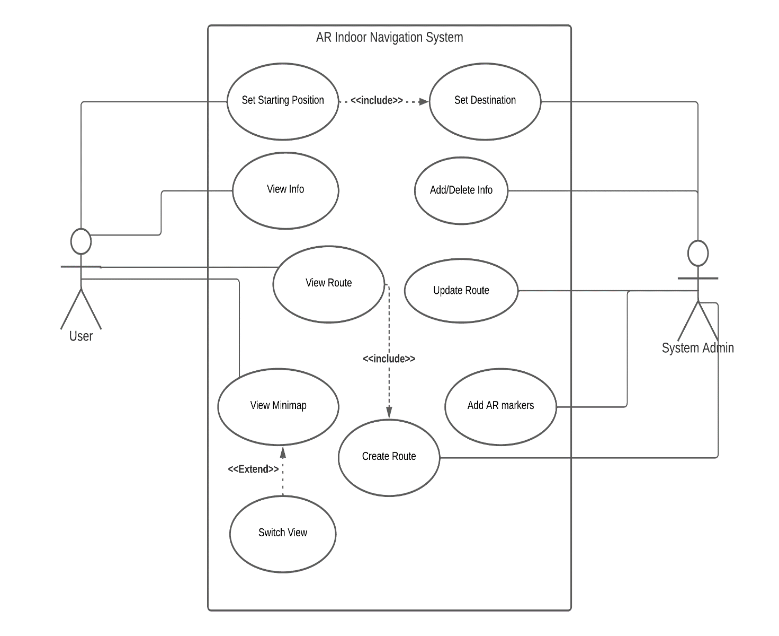

*Figure 1: Use Case Diagram for AR Indoor Navigation System*

## **4.2 DFD (DATA FLOW DIAGRAM)**

### **DFD LEVEL 0**

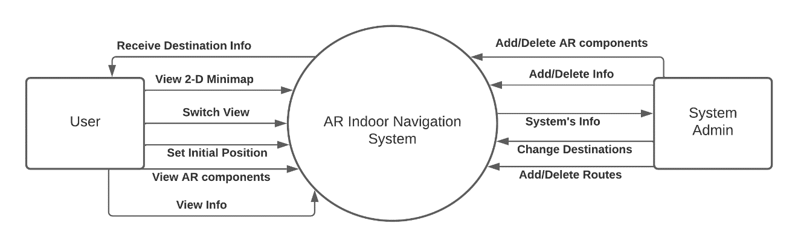

*Figure 2: DFD Level 0 Diagram*

### **DFD LEVEL 1**

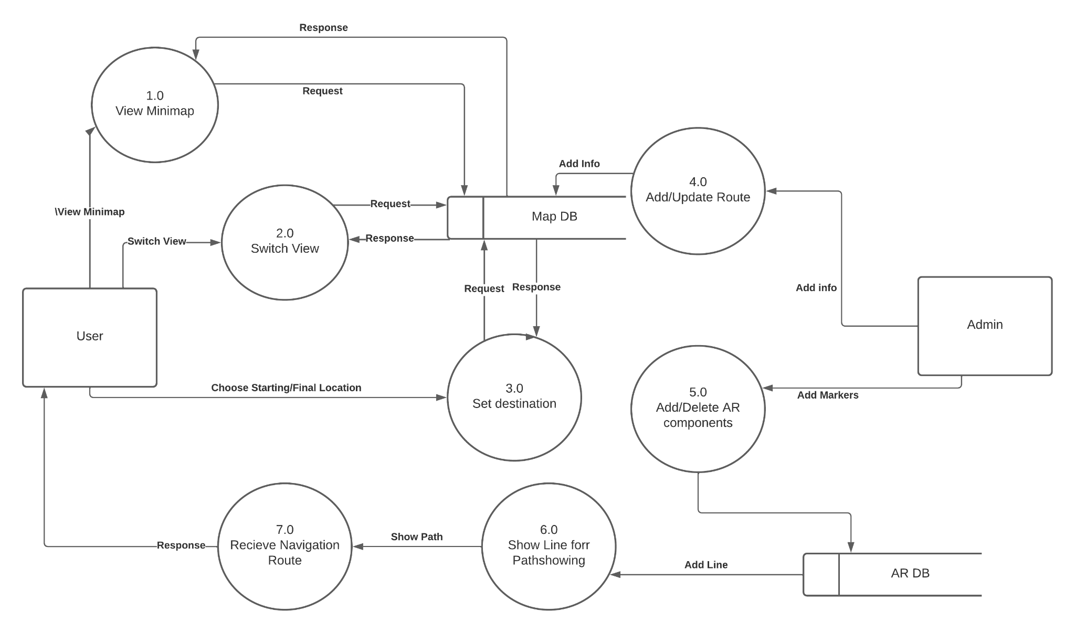

*Figure 3: DFD Level 1 Diagram*

### **DFD LEVEL 2**

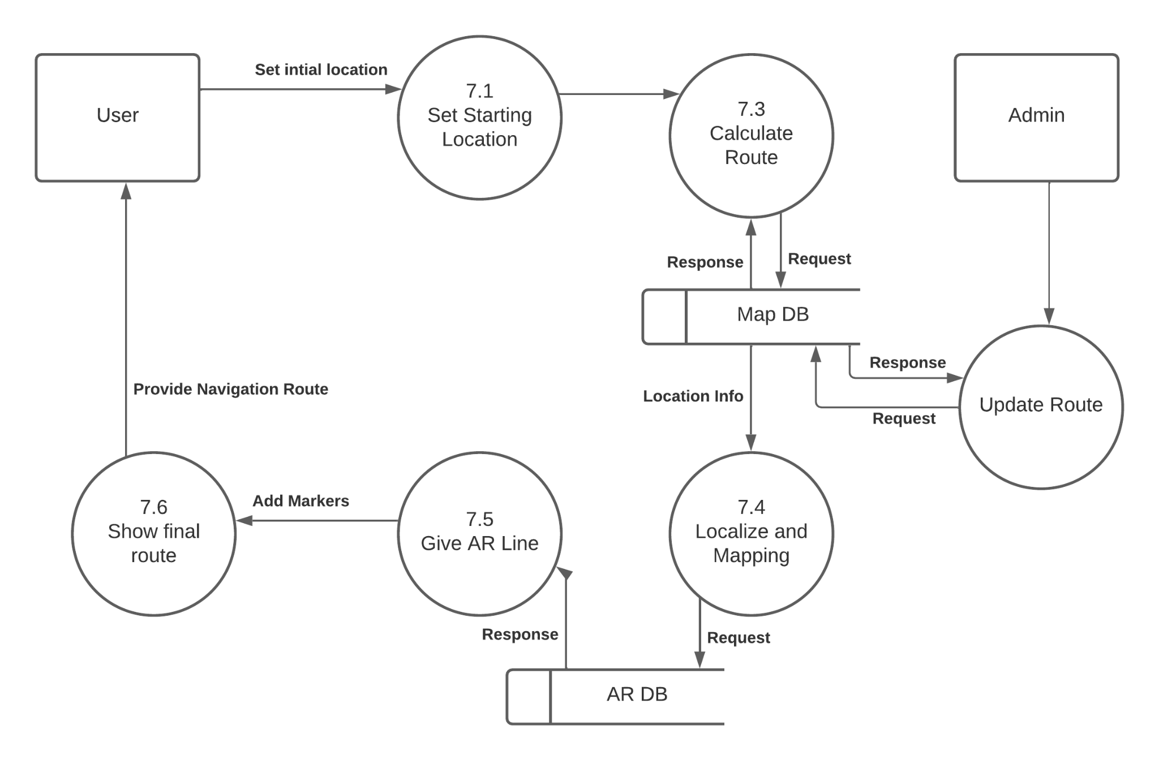

*Figure 4: DFD Level 2 Diagram*

# **CHAPTER 5**

# **METHODOLOGY**

## **5.1 ALGORITHMS**

### **5.1.1 SLAM (Simultaneous Localization and Mapping)**

For Augmented Reality, the device has to know 3D position in the real world. It is calculated through the spatial relationship between itself and multiple key points. This process is called Simultaneous Localization and Mapping. SLAM is used to build a map of the environment and it will help locate the device in that environment.

It consists of four parts,

1. **Sensor data**: It includes the camera, accelerometer and gyroscope.
2. **Front end**: The features of the 3-D map are aligned with key points along with simultaneous tracking.
3. **Back end**: It focuses on establishing relationships with different frames, localizing camera and geometrical reconstruction.
4. **SLAM estimate**: It contains the final result of the tracked features and their location and relation with camera position.

SLAM technology uses a camera feed to get feature points. They are separate geographical locations taken as feature points. ARCore’s SLAM algorithm uses different sensors like accelerometers to get corresponding spatial coordinates. ARCore handles motion tracking and environmental understanding so that they can be used more conveniently[5].

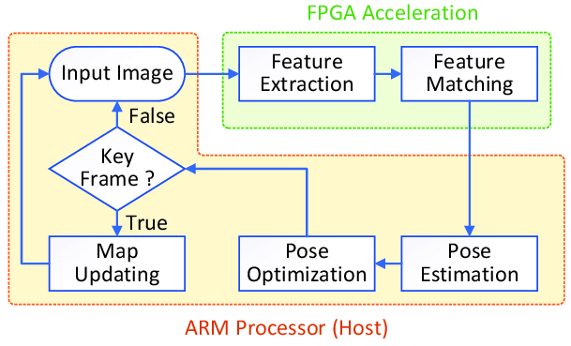

(source: [*Visual SLAM algorithm framework. | Download Scientific Diagram (researchgate.net)*](https://www.researchgate.net/figure/Visual-SLAM-algorithm-framework_fig1_333335361))

### **5.1.2 Unity’s Navigation Mesh**

Navigation Mesh also known as NavMesh in Unity is a part of the navigation and pathfinding system in Unity. The navigation system allows an agent to intelligently move

around the scene using navigation meshes. Navigation meshes are automatically created from the scene geometry[10], [11]. As the scene changes A* Algorithm is repeatedly running to give objects in a scene a sense of navigable area and location of obstacles.

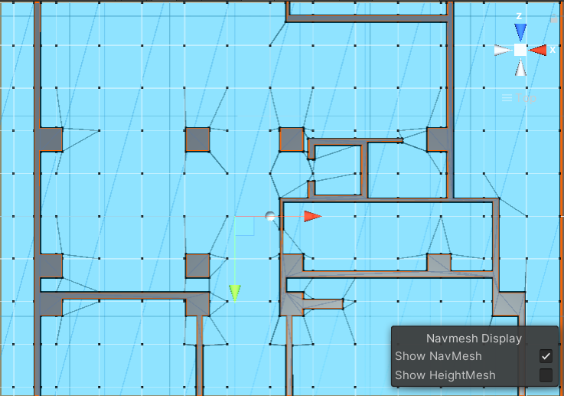

*Figure 5: Unity's Navigation Mesh - Top View*

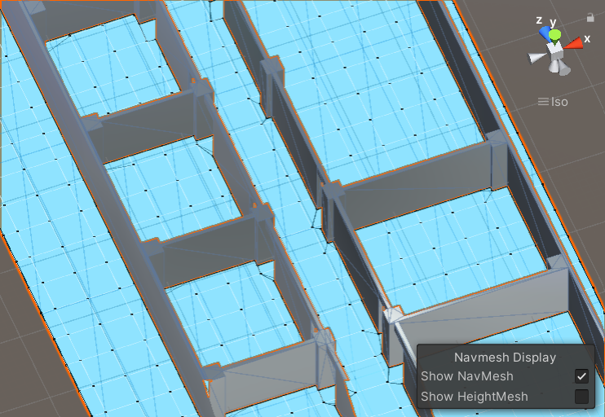

*Figure 6: Unity's Navigation Mesh - Isometric View*

Unity’s NavMesh system consists of the following components:

1. **NavMesh**

NavMesh is a data structure which describes the walkable surfaces of the scene and allows agents to find a path from one walkable location to another. The data structure is built, or baked from the level geometry.

1. **NavMesh Agent**

A NavMesh Agent is a component that helps create objects which avoid each other while moving towards their goal. Agents are capable of avoiding each other as well as obstacles in the scene and also reason about the game world using the NavMesh.

1. **Off-Mesh Link**

Off-Mesh Link component allows you to incorporate navigation shortcuts which cannot be represented using a walkable surface.

1. **NavMesh Obstacle**

NavMesh Obstacle can be used to describe how to avoid moving obstacles while navigating the world. The agents try their best to avoid a moving obstacle but once the obstacle becomes stationary it will carve a hole in the navmesh so that the agents can change their paths to steer around it, or if the stationary obstacle is blocking the path way, the agents can find a different route.

## **5.2 SOFTWARE DEVELOPMENT MODEL**

### **5.2.1 Agile Methodologies**

We are using Agile methodologies for the development of this App. It is a way to manage a project by breaking it up into several phases. Once the work begins, teams cycle through a process of planning, executing, and evaluating. As it involves constant collaboration and working in iterations we get valuable feedback from end users which makes it more flexible and easier to implement. 

### **5.2.2 Programming languages**

**C#** is a simple, general purpose, multi-paradigm programming language. C# is very much based on C and C++ programming languages. C# encompasses static typing, strong typing, imperative, declarative, functional, generic, component-oriented programming disciplines. It is comparatively faster than other object-oriented languages. Its main advantage is portability which makes it easier for those already familiar with C and C++ making it highly suitable for writing applications and developing applications.

## **BLOCK DIAGRAM**

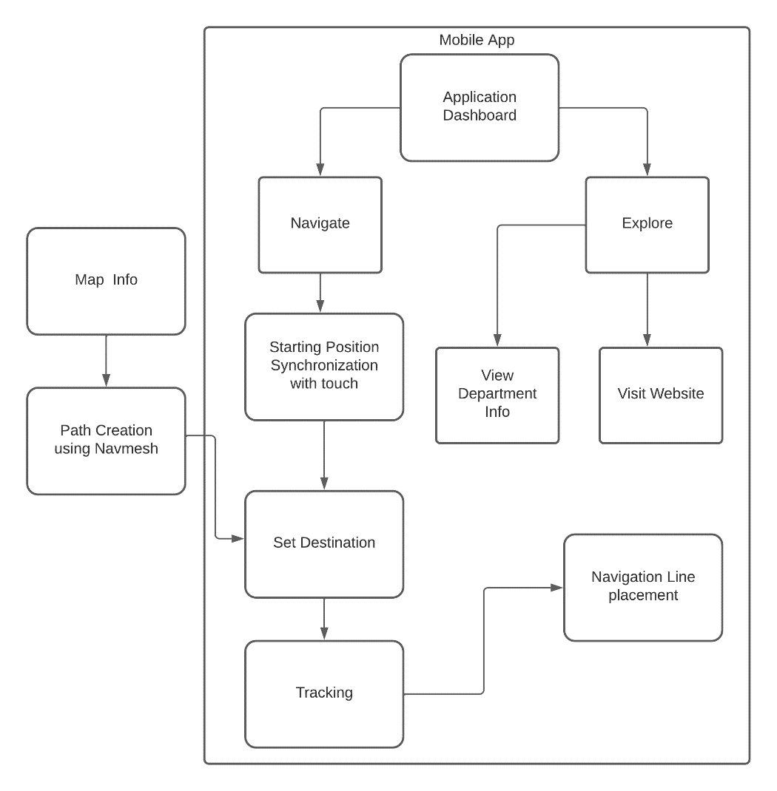

*Figure 7: Block Diagram of Indoor AR Navigation of ACEM*

The mobile application helps users navigate the third floor of ACEM college. Once the user opens the application they can view the application dashboard. The user can click on navigation button and destination will be set. The system uses a NavMesh component to determine the path from starting point to the destination. A line is visible in the real world and users can follow the line to the set destination.

# **CHAPTER 6**

# **EXCEPTED OUTPUT**

## **6.1 MOBILE APPLICATION**

*Figure 8: Output for AR Indoor Navigation System of ACEM*

A Minimap in 2D is shown with a small dot indicating the current location and following the path to destination.Minimap is a miniature map that is typically placed in the corner of the screen.

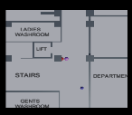

*Figure 9: Minimap for Indoor Navigation*

Minimaps are known for displaying information about our surroundings. Minimap is centered on the object and the user is able to switch view from mini-map to full screen view so that the lines are easily visible and the information can be easily recognized by the user.

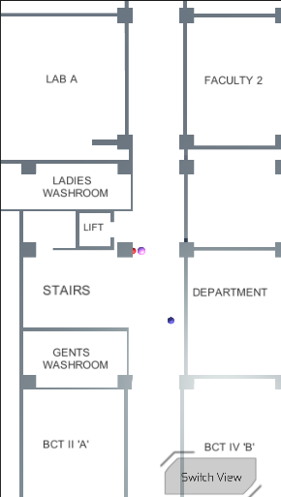

*Figure 10: Switch View for Minimap*

# **CONCLUSION**

## **7.1 CONCLUSION**

The AR Indoor Navigation System of Advanced College of Engineering provides an easy solution to students and guests. It provides visitors with an interactive experience through Augmented Reality. The use of SLAM in the indoor navigation system helps the device get knowledge of our environment and map it. Unity’s Navigation Mesh is used for defining walkable and non-walkable surfaces for the object to interact with in the 3-D real life scale of the floor plan. The MiniMap and Switch View enables users to access a 2D map of the third floor which will further help in the navigation of the college. The user can visit the college website for more information regarding the college and course information. The Explore page in the application gives information regarding various departments making the application informative.

## **7.2 LIMITATION OF THE STUDY**

Currently, the Indoor Navigation System is limited to the third floor of the college. Users can navigate through limited options like lobby, class, laboratory and exit. Another limitation of the system is that the user has to return to the initial position every time to choose a new destination. Since the start position is already predefined, start position synchronization is only possible from the exact position. The real time position of the user should match the position of the sphere indicating the person in the 3-D model in Unity. If the application is opened at any other location the navigation will not be accurate. The position of the user’s mobile phone should be at a certain height from the floor. The phone should be at least one meter away from the floor and height from the floor should not be very high or very low.

## **7.3 FUTURE ENHANCEMENT**

The Indoor Navigation System can be more accurate. QR codes can be kept at multiple positions for Start Position synchronization which will be more user friendly. Users will not have to return to the same position for synchronization, thus making the system more efficient. Augmented Reality lines can be modified into arrows that appear and disappear as the user moves.

# 

# **REFERENCES**

[1] J. I. Rubio-Sandoval, J. L. Martinez-Rodriguez, I. Lopez-Arevalo, A. B. Rios-Alvarado, A. J. Rodriguez-Rodriguez, and D. T. Vargas-Requena, “An indoor navigation methodology for mobile devices by integrating augmented reality and semantic web,” *Sensors*, vol. 21, no. 16, Aug. 2021, doi: 10.3390/s21165435.

[2] S. C. J, S. Dileep, S. C. S, and L. Elizabeth Sunny, “INDOOR NAVIGATION SYSTEM USING AUGMENTED REALITY,” *International Research Journal of Engineering and Technology*, 2021, [Online]. Available: www.irjet.net

[3] S. Kasprzak, A. Komninos, and P. Barrie, “Feature-based indoor navigation using augmented reality,” in *Proceedings - 9th International Conference on Intelligent Environments, IE 2013*, 2013, pp. 100–107. doi: 10.1109/IE.2013.51.

[4] “Augmented Reality Navigation & Indoor Positioning Guide 2021.” https://mobidev.biz/blog/augmented-reality-indoor-navigation-app-developement-arkit/ (accessed Feb. 23, 2022).

[5] “Basics of AR: SLAM – Simultaneous Localization and Mapping – andreasjakl.com.” https://www.andreasjakl.com/basics-of-ar-slam-simultaneous-localization-and-mapping/ (accessed Feb. 23, 2022).

[6] “Overview of ARCore and supported development environments  |  Google Developers.” https://developers.google.com/ar/develop/?fbclid=IwAR3jftBBUsqHjZ04GbFw58k6KY8VGpFxsUHq85E6h_7kDHowI6IxHycFcR8 (accessed Feb. 23, 2022).

[7] “About AR Foundation | AR Foundation | 4.1.9.” https://docs.unity3d.com/Packages/com.unity.xr.arfoundation@4.1/manual/index.html (accessed Feb. 23, 2022).

[8] Di. Chatzopoulos, C. Bermejo, Z. Huang, and P. Hui, “Mobile Augmented Reality Survey: From Where We Are to Where We Go,” *IEEE Access*, vol. 5. Institute of Electrical and Electronics Engineers Inc., pp. 6917–6950, 2017. doi: 10.1109/ACCESS.2017.2698164.

[9] “GO Map & IndoorAtlas - Getting started - GO Map - Unity 3D Asset.” https://gomap-asset.com/indoor-atlas/ (accessed Feb. 23, 2022).

[10] “Navigation Using NavMash in Unity 3D | Studytonight.” https://www.studytonight.com/game-development-in-2D/navigation-using-navmash (accessed Feb. 23, 2022).

[11] “Unity 3D AI: NavMesh Navigation.” https://www.binpress.com/unity-3d-ai-navmesh-navigation/ (accessed Feb. 23, 2022).